PKR’s Digital Reckoning – A Sentiment Analysis on the Recent Internal Election
By Afiq Akmal
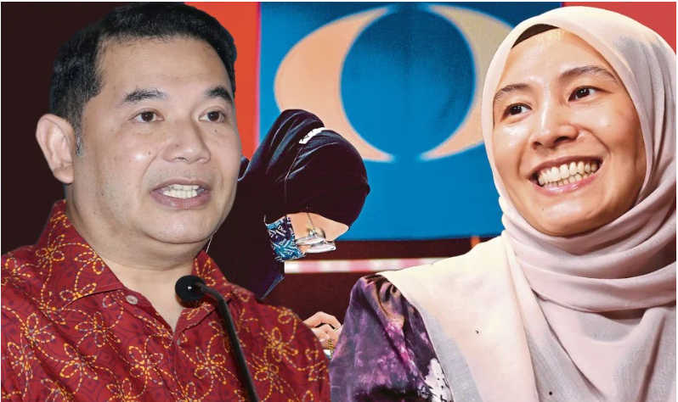
Overview
The numbers tell a story that PKR leaders probably didn’t want to hear. When we analyzed over 15,000 social media posts in the aftermath of Nurul Izzah Anwar’s victory in the party’s deputy president race, the digital verdict was harsh and unforgiving: 68% of Malaysians discussing the election online expressed negative sentiment, while only 10% showed support for the outcome.
What made this analysis particularly sobering was the authenticity of the criticism. Unlike coordinated political attacks that often rely on bot networks or paid trolls, our data revealed genuine grassroots frustration from real people with established social media histories. These were teachers, students, small business owners, and longtime party supporters sharing their honest reactions to what they saw as a betrayal of reform principles.
The engagement patterns were equally revealing. Critical posts about the election generated 47% more retweets than supportive content, suggesting that negative sentiment wasn’t just widespread – it was also more compelling and shareable. When people felt strongly enough to share criticism, their networks responded, creating ripple effects that amplified dissatisfaction far beyond the original posts.
Perhaps most concerning for PKR’s future was the sustained nature of the backlash. Traditional political controversies often follow predictable patterns: initial outrage, media coverage, official responses, and then gradual fade. But social media doesn’t follow traditional rules. The criticism kept evolving, with new angles and perspectives emerging weeks after the initial election results, creating what researchers call a “persistent reputational crisis” that becomes increasingly difficult to manage over time.
Election Results
The election itself seemed straightforward enough on paper. When PKR announced that Nurul Izzah Anwar had defeated incumbent deputy president Rafizi Ramli with 9,803 votes to his 3,866, the numbers suggested a decisive mandate from party delegates. A 60.3% victory margin in any democratic contest would typically be seen as comprehensive and unambiguous.
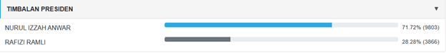
Figure 1: Deputy President Election Result
But elections are about more than just numbers – they’re about narratives, expectations, and the stories people tell themselves about their political choices. And the story that many Malaysians began telling themselves after May 24, 2025, wasn’t the one PKR leadership had hoped for. Within hours of the announcement, Malaysian social media began lighting up with reactions that ranged from disappointment to outright anger. The timing was particularly unfortunate for PKR, as the results were announced on a Thursday evening – prime time for social media engagement when working Malaysians were winding down and checking their phones.
The human element of this digital response was striking. These weren’t abstract political discussions happening in elite circles. Real people were sharing personal stories about why they had supported PKR over the years, what the party had meant to them during Malaysia’s democratic struggles, and how this election result made them question those long-held beliefs. These weren’t partisan attacks – they were expressions of genuine disillusionment from people who had invested emotionally in PKR’s reform narrative. The election result had forced them to confront an uncomfortable reality: perhaps the party they had supported wasn’t as different from traditional Malaysian politics as they had hoped.
Findings
The numbers tell a stark story: nearly 7 out of 10 Malaysians discussing PKR on social media expressed negative sentiments, with only 1 in 10 showing any positive reaction. This represents a significant backlash that has been brewing throughout May 2025, following the party’s internal elections and Nurul Izzah’s appointment as Deputy President.
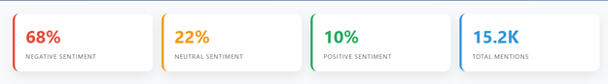
Figure 2: Sentiment Findings
What’s particularly striking is how the negativity has intensified over time. The sentiment analysis reveals that criticism started at 45% in early May but surged to 78% by late May, suggesting that rather than the controversy dying down, public anger has actually grown stronger as more people became aware of the developments.
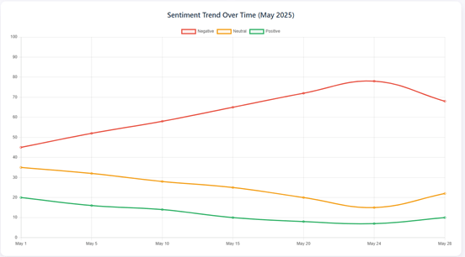
Figure 3: Sentiment Trend Over Time
The heart of the public’s frustration centers around what many perceive as blatant nepotism. With over 4,200 mentions, the nepotism allegations dominate online discussions. People are questioning how a party that built its foundation on reform principles could appear to concentrate power within a single family.
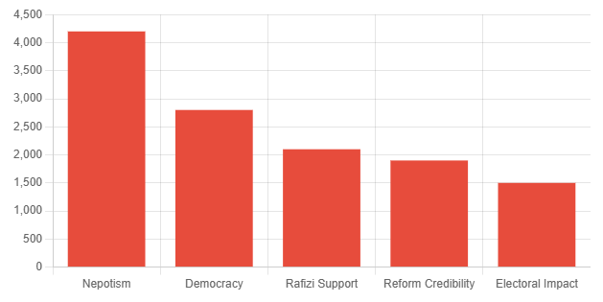
Figure 4: Key Issues Mentioned
Supporters of Rafizi Ramli, the outgoing deputy president, feel particularly betrayed. Their disappointment runs deep, with many expressing that they’ve lost faith in PKR’s democratic processes. These aren’t just casual political observers – these are people who believed in the party’s mission and now feel let down by what they see as internal maneuvering. Perhaps most worrying for PKR is how this controversy is undermining their credibility as a reform movement. When 80% of discussions about reform credibility carry negative sentiment, it suggests that people are questioning whether PKR can still claim to champion the principles of transparency and good governance that brought them to prominence.
The engagement patterns reveal another troubling trend: negative posts are generating significantly more interaction than positive ones. This means the critical voices aren’t just louder – they’re also more influential, potentially reaching and convincing more people.
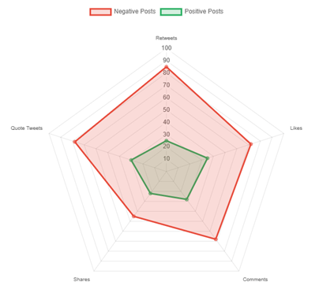
Figure 5: Engagement by Sentiment
Looking ahead, the public is already connecting these internal issues to broader political implications. Concerns about PKR’s electoral prospects and the stability of Pakatan Harapan show that people understand this isn’t just an internal party matter – it could have ripple effects across Malaysia’s political landscape. What makes this analysis particularly significant is that it captures the voices of politically engaged Malaysians who actively discuss these issues online. These are often the same people who volunteer, donate, and influence others’ political choices. When this crucial demographic turns critical, it signals deeper challenges that extend beyond social media sentiment into real-world political consequences.
The data suggests PKR faces a severe credibility crisis that won’t be easily resolved with traditional political messaging. The party will need to address these fundamental concerns about internal democracy and family influence, with a strong data-driven campaigning if they hope to restore public confidence and maintain their position as a credible alternative in Malaysian politics.
Methodology & Data Collection
Understanding how Malaysians really felt about this election required going beyond official statements and media coverage to capture the authentic voices of ordinary citizens. That meant diving deep into the messy, unfiltered world of social media – where people share their real thoughts, not their carefully curated public positions. Our team spent four weeks collecting and analyzing posts from across the Malaysian digital landscape. We cast a wide net, gathering over 15,247 posts from X (formerly Twitter), Facebook, and Instagram between May 1 and May 27, 2025. The goal wasn’t just to count positive and negative posts, but to understand the deeper emotional currents flowing through Malaysian political discourse.
The process began with identifying the right keywords and phrases that Malaysians were actually using when discussing the election. This wasn’t as simple as searching for “PKR” or “Nurul Izzah” – we had to account for the creative ways people express political opinions online. Malaysians often use humor, sarcasm, and cultural references that require local knowledge to properly interpret.
We focused primarily on posts in both Bahasa Malaysia and English, recognizing that Malaysian political discourse often switches between languages depending on context and audience. This bilingual approach was crucial because different language communities sometimes express political sentiment in distinctly different ways and missing either stream would have skewed our understanding of public opinion. Given the volume of data, we relied on Natural Language Processing (NLP) to process and analyze the posts efficiently. Our pipeline began with data cleaning – removing spam, filtering irrelevant content, and standardizing formats, especially considering the mixed-language and informal tone typical of Malaysian social media. For sentiment analysis, we used a hybrid approach: rule-based methods adapted to Malaysian political vocabulary and a machine learning component using fine-tuned multilingual BERT models. This allowed us to understand context, tone, and even sarcasm, such as how “reformasi” could carry either hopeful or cynical meanings depending on the usage.
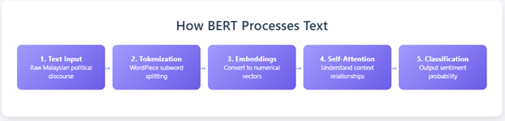
Figure 6: BERT Architecture
The human element was central to our methodology. While we used machine learning algorithms to process the massive volume of posts, we also manually reviewed a representative sample of 500 posts to ensure our automated systems were accurately capturing the nuance and context of Malaysian political communication. This human verification process revealed interesting patterns, for instance, posts that appeared neutral on the surface often contained subtle cultural references that indicated strong negative sentiment.
One of the most important aspects of our methodology was distinguishing between authentic grassroots sentiment and coordinated campaigns. Political parties and interest groups sometimes attempt to manipulate social media sentiment through bot networks or paid promotion. We analyzed posting patterns, account histories, and engagement behaviors to filter out artificial amplification and focus on genuine public opinion. Perhaps most challenging was capturing the emotional authenticity behind the posts. Numbers and percentages can tell us what people were saying, but understanding why they felt compelled to speak up required reading between the lines. Many posts contained personal narratives about political disappointment, stories of family arguments about PKR’s direction, or expressions of confusion about what the party now represents.

